3D Printed Movable Tactile Pictures for Children with Visual Impairments to Learn Mobility

| 1st Author Name  Affiliation  Address  e-mail address  Optional phone number | 2nd Author Name  Affiliation  Address  e-mail address  Optional phone number | 3rd Author Name  Affiliation  Address  e-mail address  Optional phone number |
| --- | --- | --- |

# ABSTRACT

Paste the appropriate copyright/license statement here. ACM now supports three different publication options:

* ACM copyright: ACM holds the copyright on the work. This is the historical approach.

This text field is large enough to hold the appropriate release statement assuming it is single-spaced in TimesNewRoman 8 point font. Please do not change or modify the size of this text box.

Every submission will be assigned their own unique DOI string to be included here.

Updated 7/30/2014. In this sample paper, Sheridan Printing Co., Inc. describes the formatting requirements for SIGCHI Conference Proceedings, and this sample file offers recommendations on writing for the worldwide SIGCHI readership. Please review this document even if you have submitted to SIGCHI conferences before, some format details have changed relative to previous years.

## Author Keywords

Tactile Pictures; 3D Printing; Fabrication

## ACM Classification Keywords

H.5.m. Information interfaces and presentation

# INTRODUCTION

Movable pictures are common in children’s books and they provide tremendous benefits to a young child’s development of emergent literacy. PopUp books and Lift-the-flap books have taken a role of interaction triggers. By flipping a small part of the page, children were able to learn spatial concept, and mobility. Figure 2 shows a good example of interaction from *What’s the opposite?* book*,* that allows children perceive concepts of opposite spatiality such as up/down and lost/found. Children learn how to uncover object under the comforter from flipping interaction that discover a dog behind or beneath the other. These triggers enable a child to connect kinetic experiences (flipping) with visual experiences (a dog appears).

For children with visual impairment, however, the benefits of movable pictures in children books are limited. A VI child may still get the kinetic experiences but without the corresponding visual experiences. For example, a child can still flip the flap but is unable to see the dog underneath nor can a child know the flap is actually a part of a blanket.

3D printing has been shown to be a promising method to make pictures in children books accessible to VI children. A picture can be 3D modeled as a tactile picture that can be touched, felt, and understood by a blind child. We published a series of 3D printed tactile books that visually impaired children can touch and feel. Figure XX shows some pages of 3D printed *Goodnight Moon,* and *Harold and Purple Crayon*. By printing 3D tactile pictures of visualized features, visually impaired children can touch and feel the object, and follow the context of the text, cultivate emergent literacy.

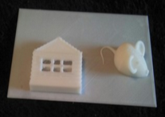 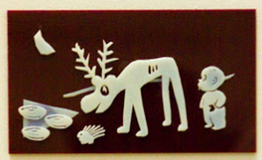

**Figure 1. 3D printing is a promising technology for making tactile pictures for children with visual impairment.**

However, current 3D-printed tactile pictures are limited to children’s books with static pictures. Techniques developed for making static tactile pictures may not apply to the task of making movable tactile pictures. Movable tactile pictures pose several challenges. We identified three to address in this paper:

1. **Moving Primitives:** There is a rich set of tangible interactions already seen in children books. How can we model movable parts that can be flipped, spin, or pulled by a child?
2. **Visual Effects:** How can we make a tactile object appear or disappear? How can such visual experiences be controlled or triggered by a tactile movement?
3. **Reusability:**  To what extent a model for a moving primitive or a visual effect can be reused for another picture with similar moving characteristics?

## Lift-the-Flap Books as Interaction Trigger

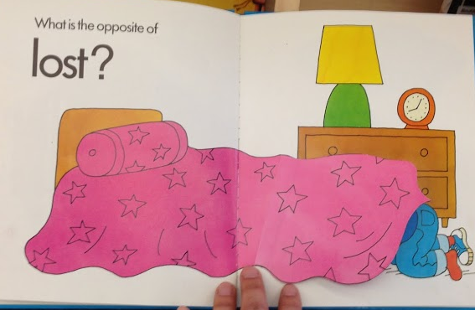 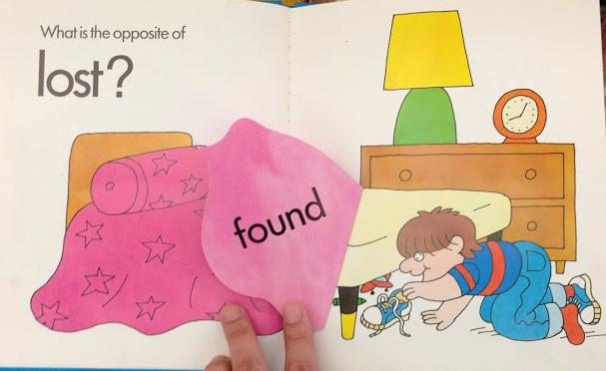

**Figure 2. Images of toys are found behind the comforter, by lifting a flap, in the “What’s the Opposite?” book**

# Related works

3D printing has risen up a promising method for helping parents to replicate tactile books and share designs via online community. [Kim] These tactile pictures books printed in 3D help children with visual impairment develop emergent literacy, by coreading the book with their parents and teachers along with the 3D printed context of each page. [Stangl] They create unique spoken stories according to children’s interests since every kids are unique. Since 3D printing reduce Jie qi et al [Ref] found adding movable and interactive objects on children book drags children’s curiosity. Physical interaction triggers by push and pull, or spinning attracted children’s interests into the book. However, there is limitation that those interactions gives visual feedback, turning on and off lights, that visually impaired children are not able to see.

# formative study

How would a person approach to the task of designing a movable tactile picture?

First, we considered who would be an ideal person for creating movable tactile pictures. This person must be knowledgeable of 3D modeling and printing and of the needs of a blind child. Let us use the task of illustrating a page with rocket behind the cloud. We studied this by using a laser cutter. This person would (1) design curvy clouds, (2) abstract rocket shape in young children level, (3) model a hinge which is mathematically designed to uncover cloud so that not stuck inside during printing, and (4) combine cloud and a rocket with hinge to make the page flappable.

Second, we considered how a person without professional skills would approach to this problem. We organized a workshop [science discovery].

## DESIGN PROCESS

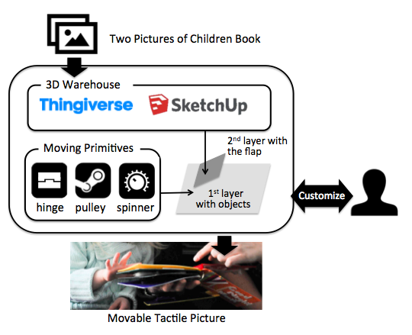

**Figure 5. The system takes two pictures as input, generate 3D printable moving-tactile picture file.**

We present a novel process for creating 3D printed movable tactile pictures for children with visual impairment. The input to this process is a picture with movable parts from a children’s book. The output from this process is a 3D-printable movable *tactile* picture designed to provide equivalent (or similar) kinetic and visual experiences to VI children.

1. **Interpretation:** The human designer interprets the prominent content of the picture. It searches 3D warehouse or Sketckup or Thingiverse for suitable models for each component. Alternatively, a skilled modeler can create a model from scratch.
2. **Movements:** The human designer selects the appropriate moving primitives from a set of already modeled primitives.
3. **Visual effects:** The human designer defines the visual effects. For instance, select the before/after model for a “flip-to-change” visual effect.
4. **Synthesis:** A computer program automatically synthesizes a tactile model (combining tactile models with movable primitives).
5. **Customization:** The human designer customizes certain aspects, such as the position of an object on the page or the number of object, the size and kinds of objects represented on the book.

Supporting this process requires us to deal with four research challenges, which we describe next.

# modeling moving primitives

We surveyed N children books with movable pictures. We wanted to understand a range of kinetic experiences provided by these books. We identified four most common classes of movements and researched on how to model them. Our method is to first prototype using wood and a laser cutter, and then model in 3D software. The outcome is a vocabulary of movable primitives that can be added to tactile pictures to make them movable.

**Hinges**

Traditionally, the door of house is the most common objects used for lift-the-flap book. Connection between doors and walls by hinge primitives are defined by two pictures of closed visual and opened visual.

|  |  |  |
| --- | --- | --- |
| [example from a real book] | Macintosh HD:Users:qubick:Desktop:Screen Shot 2014-09-04 at 9.21.40 AM.png | Macintosh HD:Users:qubick:Desktop:Screen Shot 2014-09-02 at 9.39.30 PM.png |

## Pulley

Pulley is one of most versatile primitive to be adapted to any kinds of interaction. The pulley, as a part mechatronics, can trigger movements of the picture in any direction, with any shapes.

|  |  |  |
| --- | --- | --- |
| Macintosh HD:Users:qubick:Desktop:Screen Shot 2014-09-04 at 11.29.09 AM.png | Macintosh HD:Users:qubick:Desktop:photo_3-3.JPG | Macintosh HD:Users:qubick:Desktop:Screen Shot 2014-09-02 at 9.39.51 PM.png |

A caterpillar in above figure goes through the hole by pushing it into fruits. We combined the body of caterpillar with pulley to let children pull it throughout the hole inside an apple.

**Spinner**

The most salient feature of roller is spinning attribute.

|  |  |  |
| --- | --- | --- |
| Macintosh HD:Users:qubick:Desktop:Screen Shot 2014-09-04 at 11.48.28 AM.png | Macintosh HD:Users:qubick:Desktop:Screen Shot 2014-09-04 at 11.50.05 AM.png | Macintosh HD:Users:qubick:Desktop:Screen Shot 2014-09-02 at 9.39.39 PM.png |

**Swing**

|  |  |  |
| --- | --- | --- |
| https://lh4.googleusercontent.com/v9Cj3ScwdUYD7z-GZhhsnpsCsCzAzr5iy8rOrIX0V2aBwzDdcdkZ7Oil5OS2TMnp9WASsuwoxC545dQddxj8eZQZqhzAtPvr2h9qyE9ykXgWUlD3KPegca4U0-KpFzCUwQ | Macintosh HD:Users:qubick:Desktop:Screen Shot 2014-09-04 at 3.41.40 PM.png | Macintosh HD:Users:qubick:Desktop:Screen Shot 2014-09-02 at 9.40.00 PM.png |

# MODELING VISUAL Effects

After developing a set of tactile movable primitives, our next challenge was to figure out how to combine tactile pictures with these primitives in order to achieve certain *tactile* visual effects. Our approach is to design a set of “visual effect” or animation templates. Each template is a 3D model that has one or more placeholders for attaching tactile pictures.

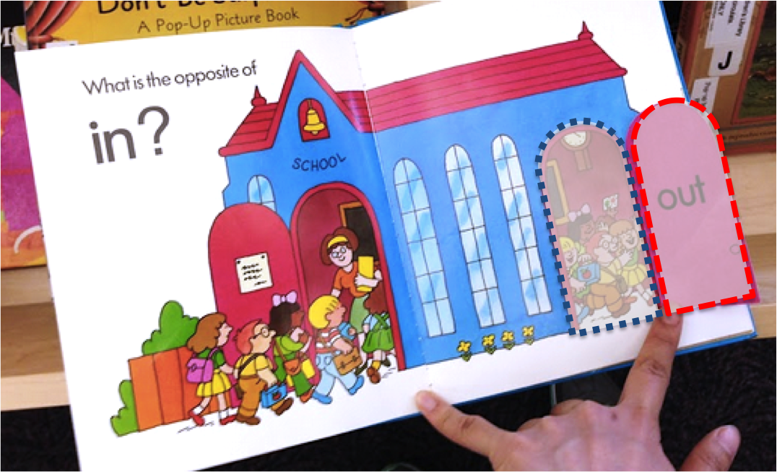 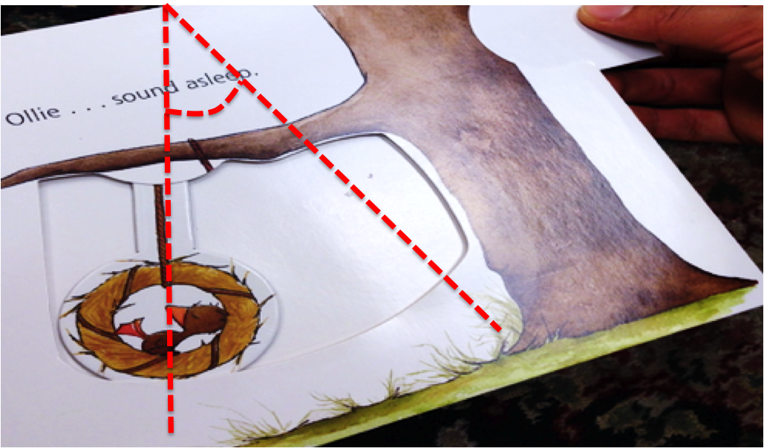 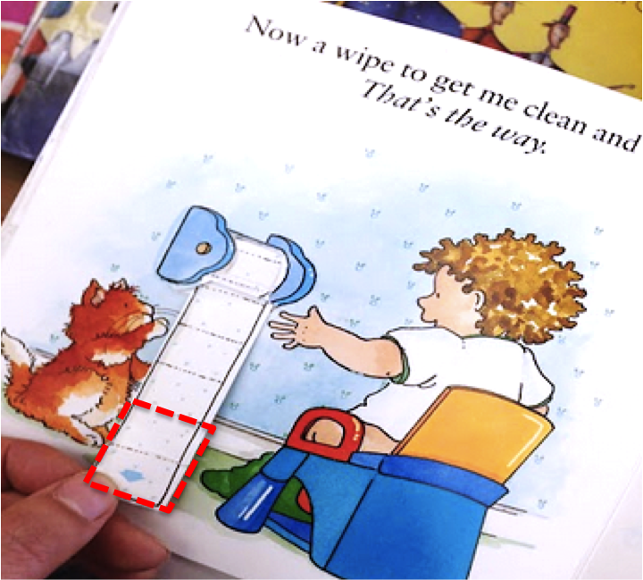

**Figure 4. (a) Left shaded area is newly come out, by being taken out right shaded area of long dashes that will be taken as movable part. (b) A part of picture in different position in angle is defined as swing or spinner.**

## X Appears

An object that was initially hidden but become visible after a child performs an action. For instance, a child *flips* a flap and reveals an animal underneath. The flap does have any tactile pattern. A tactile pattern should be placed underneath the flap. To define an *appear* effect, a designer needs to specify only one tactile picture.

The appear effect fits most naturally with the “hinge” moving primitive that supports the flip action.

Our task is to design a template model where tactile picture can be held. It is similar to a “Powerpoint” template with different containers for headers, body, footer where a person can drop contents in. In this case, the template model has one container to hold the picture underneath.

|  |
| --- |
| Macintosh HD:Users:qubick:Desktop:Screen Shot 2014-09-04 at 10.59.08 AM.png |

## X Disappears and Y Appears

A slightly more complicated effect is one that involves two objects X and Y, where X is covering Y. For example, a cloud covers a rocket. In this case, the template has two containers. One for the picture above (i.e., X, window hiding the moon) and the other for the picture underneath (i.e., Y, moon behind the window). A designer needs to specify two tactile pictures, one for the X and one for Y.

|  |
| --- |
| Macintosh HD:Users:qubick:Desktop:diagram.png |

These are two examples of images placed on the hinge.

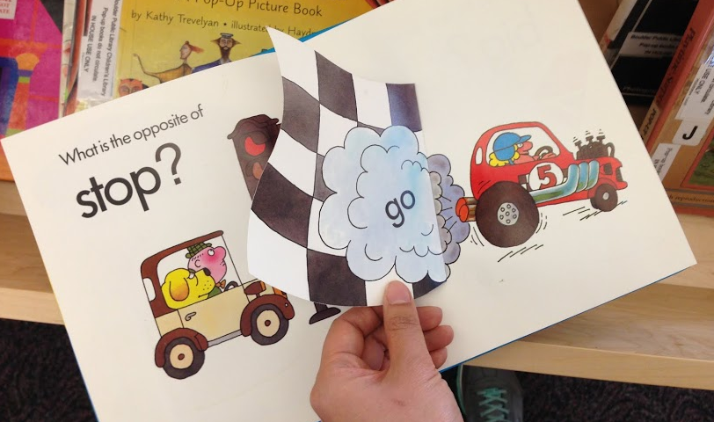 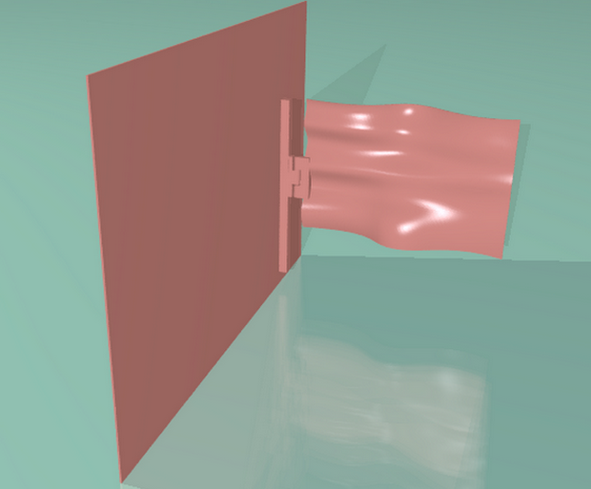

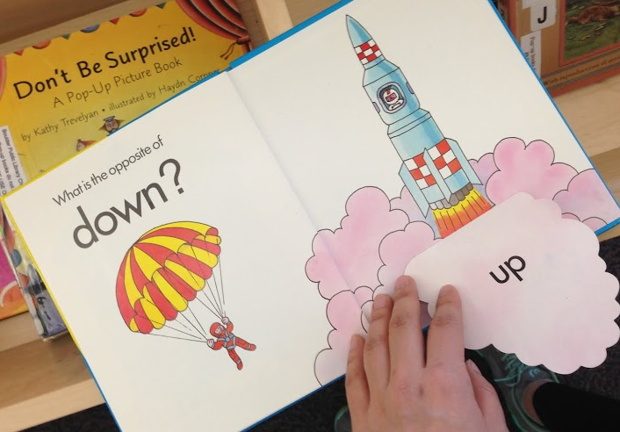 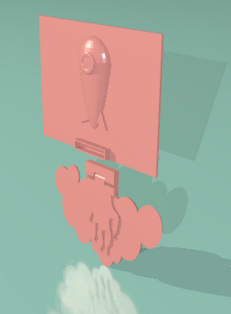

**Figure. A flag combined with hinge to flap (above) and a rocket beneath the cloud (below)**

Our system takes two pictures of the page which is movable, in order to consist two layers of each page. The interaction type, moving primitive type in this case, is defined by image processing of these two input pictures.

From (a) in Figure 4, a small part of rounded rectangle in the first input scene is gone, and this shape is replaced with a new image in the second input scene. This specific shape is cut off from the first picture and be a second layer of flapping part, and the medium values of two images,

This is also applicable for any flapping objects, such as flag(a), cloud(b), and sail. Both tip of hinge primitive are combined to the dowel and flags in (a) of Figure XX, to represent flag’s movements in windy whether. For the second example of hinge, the back of cloud hiding rocket was combined with flames to transcribe a new scene when the flap is opened, that rocket exhumes flames. The hinge of the second application is printed separately, and fabricated to the cover like LEGO, to avoid print fail because of complexity.

## X is Changed to X’

In this visual effect, an object is still the same object but look different when a child performs an action. For instance, a child flips a flap and a bunny’s ears become longer. Or a child pulls and the toilet paper roll extends.

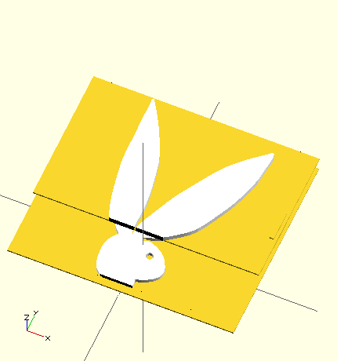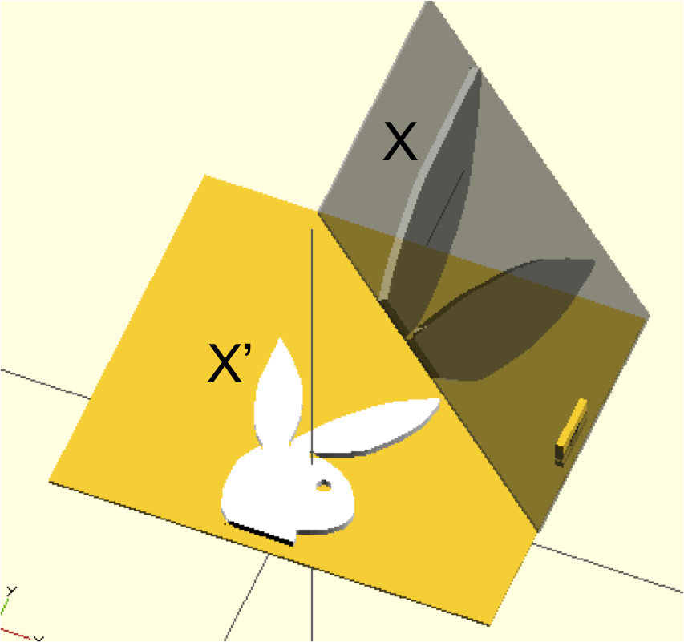

In this case, the template has three containers. One is for the part of X that does not change. The other two is for the before and after of the part of X that does change. A designer needs to specify one tactile picture and a variation to the same picture. The designer needs to also specify the area of the variation.

combination of (1) newly replaced part of second picture, children inside the door in this particular example, and (2) the entire school house image from the first input image become a first layer of tactile page. If same image is rotated, being shown in different position of in certain angle, this is translated in sway or spinner. Basic mechanism of defining a movement type works either for sway and spinner, since both movements similar but in different angle. If the limit of rotation is given or the angle of rotation is greater than given threshold, it will be defined as spinner, rather than sway.

From (a) of ***[Title]***, in Figure XX, the pulley is also connected to toilet paper to present the paper is rolling down. Also, (b) of ***Maisy Series*** book, the pulley is fabricated to the juice, to present the rest amount of juice in the glass. As the mouse drinks over the juice, children pull down the tip of pulley, by touching and feeling decreasing amount of juice. User also can imagine the slide, train that move through trails that lead visually impaired children feel mobility of those objects.

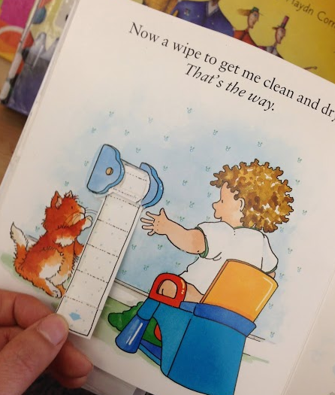 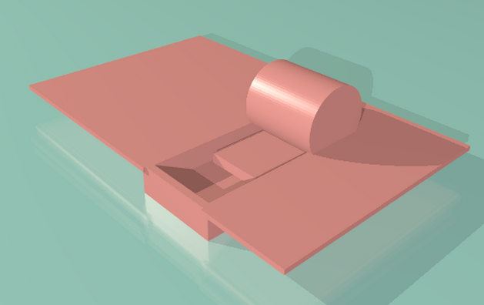

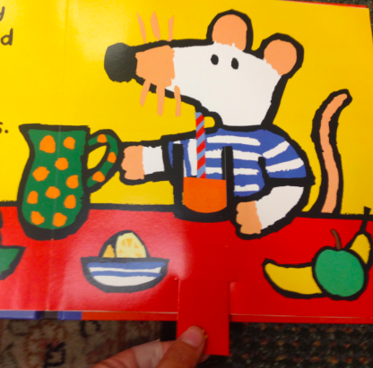 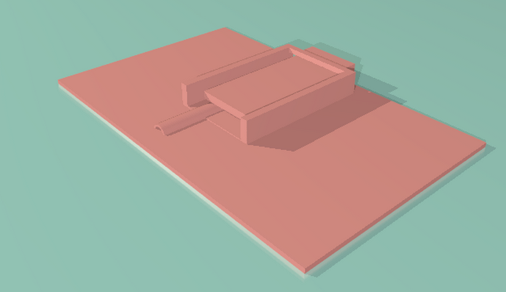

**Figure 9. Two examples of pulley primitives. A toilet paper turns out from a roll (above), and juice in the glass that reveals straw according to pulling (below)**.

## X is Moved

In this case, an object does not change its appearance. But its spatial layout is changed. For example, a Ferris wheel can be spin by a child. Or a rocket is shifted to the left when a child pulls a pulley.

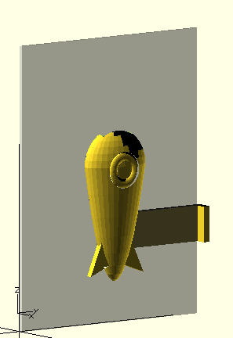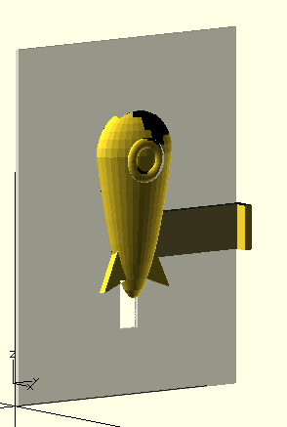

It is possible only a portion of a tactile picture is movable. For example, only the wheels of a car can be spin by a child.

|  |  |
| --- | --- |
| frUHO6Z4El7eRG7Au5vu9HIv8LngJRGN_MZYnHHUbwvLcZnzbDn0sravqwnOMvg0ouRxLbxQ2UROgQsJCtIFGOI7rmrH2PCH2N8A34ctF9r4jpA-P3Rh7TiXtiV1K3tXuQ  6lz2rhdKYP7riKlQ3ReVLdzvFDcp_sBTFWifwtmBce04VqPFRinc5kg4VVPywAtnwWz90zFtKAZ94XHE0-a5N61K4V2wR16i35BoGWWeLH88d1R9YN0zfK1hFzwjCLtHwA | v-vIOwsJ7IBunaPVfsw7BzGgHuGjiLTPyIpBP1bcI9xoquOWMtd_GN2vcL46DTJrAgtxCA_zf4Jq54d7iAqnGwV8UZvXmEBryyGKo-qFkaOl-seauv0-VQXR3mpcAiKySA  GfeqytfhhV9blLefRUHNTx3B3Ac9FTFVfKKnVvfzP14fX7GETEZ6UvnRxqfq-gkoA0xtp6ikiB7sVv4nbF_LFcO5A1EkUVLMq8z8Uuas3wt8LgKeo7z4R8zTkvkMRHCccA |

This primitive is able to be adapted to tires of a car running over street, a giant wheel in an amusement park. For those young children who has never seen ferris wheel, it will be hard to understand how car is moving (a), how giant wheel is rotating from ***All the Fun of the Fair*** (b). To be adapted as part of movable objects, roller was scaled down and copied to be integrated two tires. Roller was maximized the size to fit into large frame of a giant wheel in the second example. Parents and teachers co-read the story and children with visual impairments can touch and feel cylinder with a hole is moving around an axe, and they may interact following narratives. Numerous application ideas will rise, such as lids of a jar, LP record panel spinning over gramophone.

Figure 8. Two examples of roller application, A car from with rolling wheel (above), and a giant wheel with rolling axes (below). According to the angle of rotation, examples can be combined with swing.

## REUSABILITY

The templates can be made using 3D modeling software like Maya or Sketckup. These can be reused as long as the user knows how to use the 3D modeling software. We can have a library of Maya or Sketckup files. A user can load the template modeal, aimporat a picture, and manually drag the picture to the right place.

However, ideally, we want to automate this placement process and hide the modeling software from end-users. We want to experience to be analogous to ordering a customized photo album online. A user can use a GUI frontend to select a few pictures, then some programmatic magic underneath put these pictures together to synthesize an album, or in our case, a movable tactile picture. It would be very difficult to automate the GUI interaction needed to “drag” pictures to the right places in Sketchup or Maya. Thus, to do so, we use OpenSCAD in order to gain programmatic control of the model creation process. We built each template model as a parameterized function in OpenSCAD. Each placeholder is exposed as a parameter to a function. To generate a movable tactile picture is as simple as calling the function with the right parameter. Of course, we do not expect n end user to call this function directly. Rather, having this generative function enables us (or others) to build a GUI frontend. This GUI frontend is not the focus of our paper. But we will offer some design sketches as inspiration. Our focus is the OpenSCAD backend that makes development of a GUI possible.

An example function signature is:

appear\_effect(before\_picture, after\_picture)

## Generate Ready to Print STL Files

We developed OpenSCAD code generator that imports STL models searched from the URL using “thing number”, which is unique ID of every single 3D model in Thingiverse. The position, size and kinds of objects from warehouse and including moving primitives are adapted to our code generated as given parameter. Size of parameter defines the general scale of components, and this parameter automatically defines how much the model should be flatten to fit in volume. The system also verifies the model downloaded from warehouse is printable, manifold. Finally, the system renders the entire models, and generates ready to print STL file of the tactile picture.

## Interactive Customization of Tactile Page

In what ways hinge be customized? Size, location, opening…etc. the flap is shaped.

appear\_effect(before\_picture, after\_picture, parameters)

In the basic mode of system, users already get a ready-to-print 3D model. Once 2D visuals as input are scanned, objects which will be put on first layer are searched from online 3D warehouse such as Thingiverse [Ref], SketchUp [Ref] where a lot of practitioners, designers, and hobbyists share their professional 3D designs. Parents and TVIs do never need to design complicated and detailed real life objects. Among tons of designs in different shapes, various abstraction level of detail, etc., they only need to choose the best fitting model to import in the design. By checking appropriate sizes of the objects, users define position of object, reduce or increase the number of object placed elsewhere to add details of scene, resize model interactively. In more sophisticated mode, users can choose the perspective views of the object. For example, in one version of 3D tactile picture, the side view of a bed can be embodied, otherwise, the bottom side of the bed view can be depicted for another version of Figure 2.

# EVALUATION

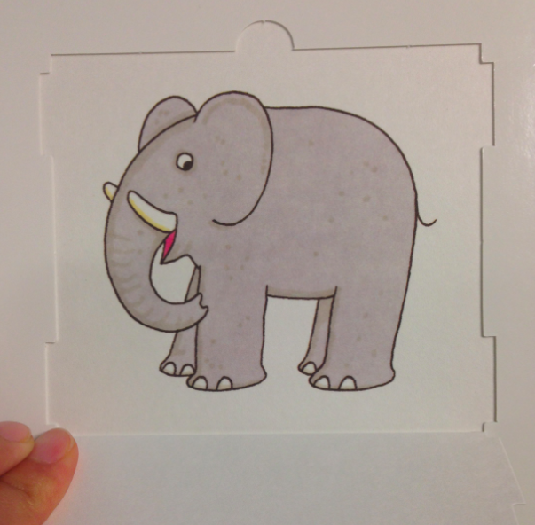 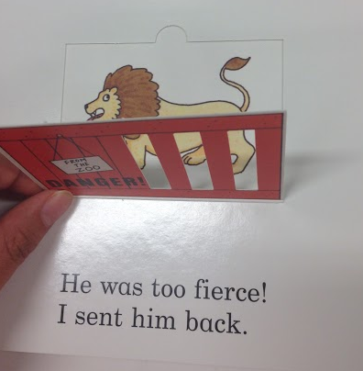 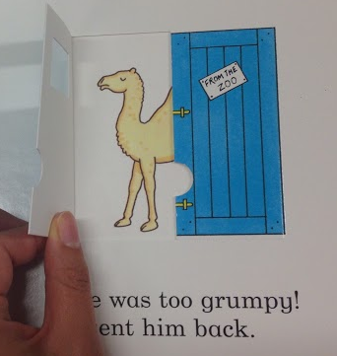 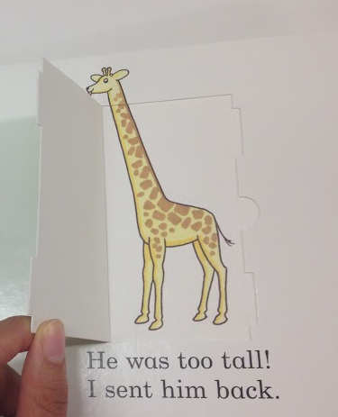 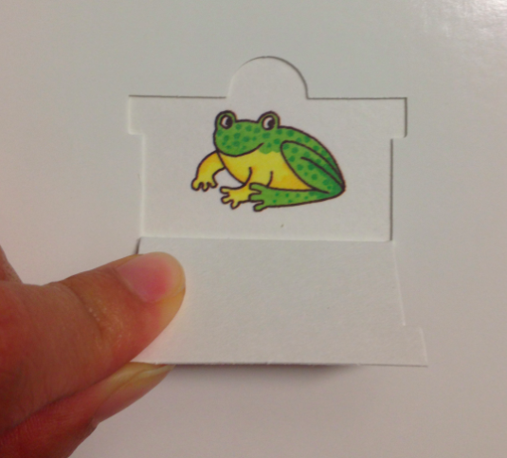 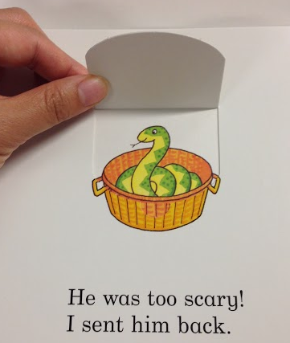 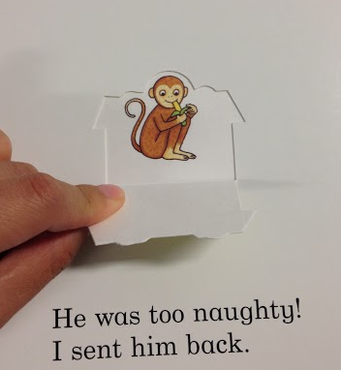 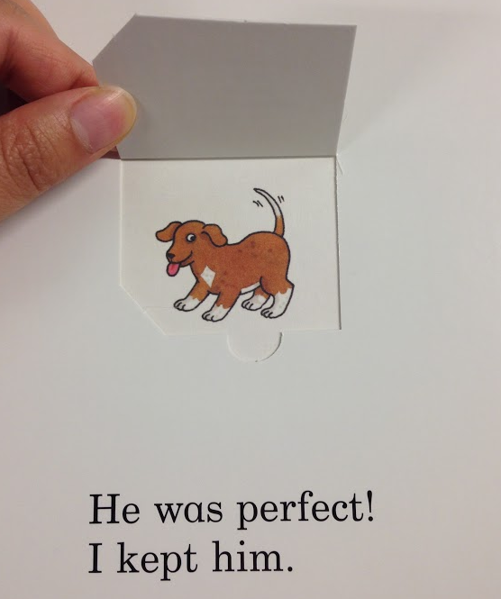

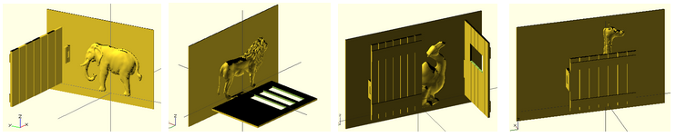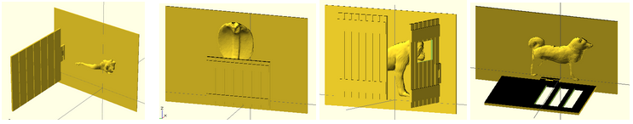

**(a) Elephant with one fence door flapping left (b) Lion with door with ribs flapping down   (c) Camel with two doors with window in the middle fliapping in two direction (d) Giraffe with a lower door showing its head over the door** **(e) Frog with one door, (f) snake head above a lower door, (g) monkey with two direction door, and (f) dog with flap down door**

**Figure 6. Eight different animal pictures with flap part of “Dear Zoo” (above) and movable tactile representation (below)**

**Dear Zoo - Reusability**

We transcribed the *Dear Zoo* into 3D movable tactile pictures book, as a whole set of the picture book. The story is focusing on very simple conception of the kinds of animal children can see from the zoo, and 2D visuals of them emphasizes features of each animal in terms of size. This is a good example book to be tested by our system, since the *Dear Zoo* is one of the most loved lift-the-flap books that manipulates simple interaction mechanism repetitively such as opening the boxes. For our users, parents need only differentiate the kinds of animal and size of the box. Optionally, the kinds of the door, which is done by changing various doors with different hinge position, lets their children to open the door in different directions. Figure 5 shows eight pages of animal with flap from the book and 3D representation of each page. Figure 5 shows eight pages of animal with flap from the book and 3D representation of each page.

## Applications of Primitives with Different Books

## Printability

Mention we sent to 3D hub to test how printable our models are.

## Design Process

We invited a mid-level expert of 3D design to explorer page variations of “Dear Zoo” book. We gave a parameter of (1) kinds of animal choice, (2) size of animal, (3) size of the door, and (4) kinds of door. He chose animals based on selection criteria, shapes and complexity of the model. Even though the animal design from online 3D warehouse looks good, if the model is too high poly, he changed his selection because it takes too long to re-render from OpenSCAD generator to get final STL file to print out. He changed the door size widely for the frog model, to fully cover the frog on the page when the flap is closed. In the same way, he scaled animal size to fit in given page back size, neither too big, nor too small, considering tactility of touch. Basically he randomly applied kinds of the door, but changed the design into side opening door if scaled animal design is too tall so that down hinge is overraped with animal’s legs.

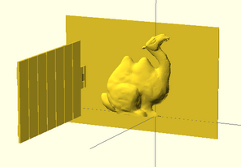 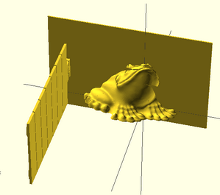 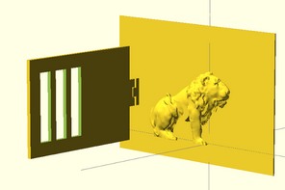 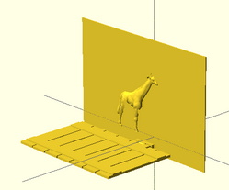

**Figure 9. Four variations of animal with different design, size, and door types.**

# Conclusion

# REFERENCES

1. Jie qi, Leah Buchery, Electronic Popables: Exploring Paper-Based Computing through an Interactive Pop-Up Book, TEI 2009
2. Kim J., Stangl A., Eisenberg A., Yeh T., Tactile Picture Books for Young Children with Visual Impairment, TEI 2014
3. Lipson H, Kurman M, Fabricated: The New World of 3D Printing p.271-275
4. Stangl A., Kim J., Yeh T., Technology for emergent literacy, IDC 2014
5. Google SketchUp 3D Warehouse https://3dwarehouse.sketchup.com/
6. MakerBot Thingiverse http://thingiverse.com
7. Go, Maisy, go!
8. Goodnight Moon
9. Harold and Purple Crayon
10. All the Fun of the Fair
11. Eric Hill, What’s the opposite?
12. Dear Zoo
13. Oliver Dunrea, Gossie Playes Hide and See